Lab8 - Structures
1.Write a C program to create a structure called student. Get details such as student id, name, age, department, year of study, address, mobile number, marks in three different subjects such as science, maths and English and print the details.
#include<stdio.h>
struct sd{
int rollno;
int age;
char name[43];
float marks[3];
char address[99];
int year;
int mobile_no;
};
int main()
{
struct sd s1;
printf("roll no.\n");
scanf("%d",&s1.rollno);
printf("name:\n");
scanf("%s",&s1.name);
printf("enter your age:\n");
scanf("%d",&s1.age);
printf("marks in three subjects\n");
for (int i=0;i<3;i++){
scanf("%f",&s1.marks[i]);}
printf("whats your year of study:\n");
scanf("%d",&s1.year);
printf("enter your mobile number:\n");
scanf("%d",&s1.mobile_no);
printf("enter your address:\n");
scanf("%
s",&s1.address);
printf("\n------student details-------\n");
printf("roll number: %d\n",s1.rollno);
printf("name: %s\n",s1.name);
printf("age: %d\n",s1.age);
printf("address: %s\n",s1.address);
printf("mobile no:%d\n",s1.mobile_no);
printf("year of study: %d\n",s1.year);
for(int i=0;i<3;i++){
printf("marks in %d subject is: %.2f\n",i+1,s1.marks[i]);
}
return 0;
}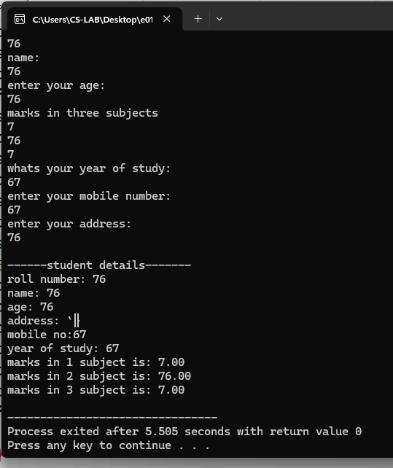

2. Write a C program to create the above student structure and get details of 10 students and print them.
#include<stdio.h>
struct sd{
int rollno;
int age;
char name[43];
float marks[3];
char address[99];
int year;
int mobile_no;
};
int main()
{
struct sd s1[10];
int i;

for (i = 0; i < 10; i++){
printf("enter details of %d student\n",i+1);
printf("roll no.\n");
scanf("%d",&s1[i].rollno);
printf("name:\n");
scanf("%s",&s1[i].name);
printf("enter your age:\n");
scanf("%d",&s1[i].age);
printf("marks in three subjects\n");
for (int i=0;i<3;i++){
scanf("%f",&s1[i].marks[i]);}
printf("whats your year of study:\n");
scanf("%d",&s1[i].year);
printf("enter your mobile number:\n");
scanf("%d",&s1[i].mobile_no);
printf("enter your address:\n");
scanf("%s",&s1[i].address);}
for (i = 0; i < 10; i++){
printf("\n------student details of %d student-------\n",i+1);
printf("roll number: %d\n",s1[i].rollno);
printf("name: %s\n",s1[i].name);
printf("age: %d\n",s1[i].age);
printf("address: %s\n",s1[i].address);
printf("mobile no:%d\n",s1[i].mobile_no);
printf("year of study: %d\n",s1[i].year);
for(int i=0;i<3;i++){

printf("marks in %d subject is: %.2f\n",i+1,s1[i].marks[i]);
}}
return 0;
}
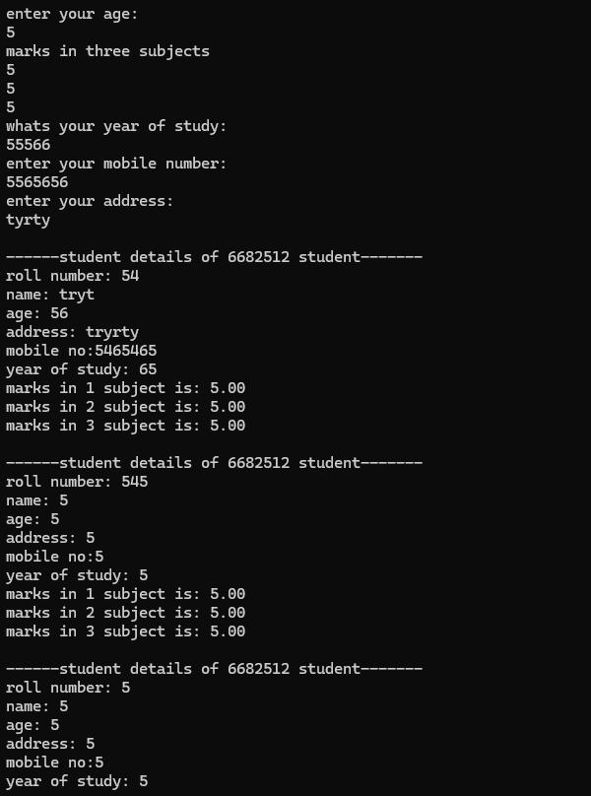
3. Write a C program to get details of 10 students and find the average and maximum marks and print the student with maximum marks using structures.
#include<stdio.h>
struct sd{
int rollno;
int age;
char name[43];
float marks[3];
char address[99];
int year;
int mobile_no;
};
int main()
{
struct sd s1[10];
int i, max_index = 0;
float total_marks[10], average, max_marks = 0.0;

for (i = 0; i < 10; i++){
printf("enter details of %d student\n",i+1);
printf("roll no.\n");
scanf("%d",&s1[i].rollno);
printf("name:\n");
scanf("%s",&s1[i].name);
printf("enter your age:\n");
scanf("%d",&s1[i].age);
printf("marks in three subjects\n");
for (int i=0;i<3;i++){
scanf("%f",&s1[i].marks[i]);}
printf("whats your year of study:\n");
scanf("%d",&s1[i].year);
printf("enter your mobile number:\n");
scanf("%d",&s1[i].mobile_no);
printf("enter your address:\n");
scanf("%s",&s1[i].address);
total_marks[i] = s1[i].marks[i];
if (total_marks[i] > max_marks) {
max_marks = total_marks[i];
max_index = i;
}
}
average = 0;
for (i = 0; i < 10; i++) {
average = total_marks[i]/10;
}
printf("\nAverage Marks: %.2f\n", average);
printf("Student with Maximum Marks:\n");
printf("ID: %d\n", s1[i].rollno);
printf("Name: %s\n",s1[max_index].name);
printf("Total Marks:%.2f\n", max_marks);
return 0;
}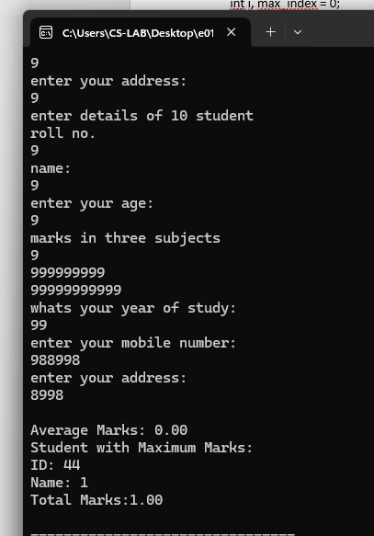

- Write a C program to create nested structure for students.
#include <stdio.h>
struct Address {
char street[50];
char city[50];
char state[50];
char zip_code[10];
};
struct Student {
int id;
char name[50];
int age;
char department[50];
int year;
struct Address address;
char mobile[15];
float science_marks;
float maths_marks;
float english_marks;
};
int main() {
struct Student s;
printf("Enter Student ID: ");
scanf("%d", &s.id);
printf("Enter Name: ");
scanf("%s", s.name);
printf("Enter Age: ");
scanf("%d", &s.age);
printf("Enter Department: ");
scanf("%s", s.department);
printf("Enter Year of Study: ");
scanf("%d", &s.year);
printf("Enter Street: ");
scanf("%s", s.address.street);
printf("Enter City: ");
scanf("%s", s.address.city);
printf("Enter State: ");
scanf("%s", s.address.state);
printf("Enter Zip Code: ");
scanf("%s", s.address.zip_code);
printf("Enter Mobile Number: ");
scanf("%s", s.mobile);
printf("Enter Marks in Science: ");
scanf("%f", &s.science_marks);
printf("Enter Marks in Maths: ");
scanf("%f", &s.maths_marks);
printf("Enter Marks in English: ");
scanf("%f", &s.english_marks);
printf("\nStudent Details:\n");
printf("ID: %d\n", s.id);
printf("Name: %s\n", s.name);
printf("Age: %d\n", s.age);
printf("Department: %s\n", s.department);
printf("Year of Study: %d\n", s.year);
printf("Address: %s, %s, %s, %s\n", s.address.street, s.address.city,
s.address.state, s.address.zip_code);
printf("Mobile: %s\n", s.mobile);
printf("Marks - Science: %.2f, Maths: %.2f, English: %.2f\n", s.science_marks,
s.maths_marks, s.english_marks);
return 0;
}
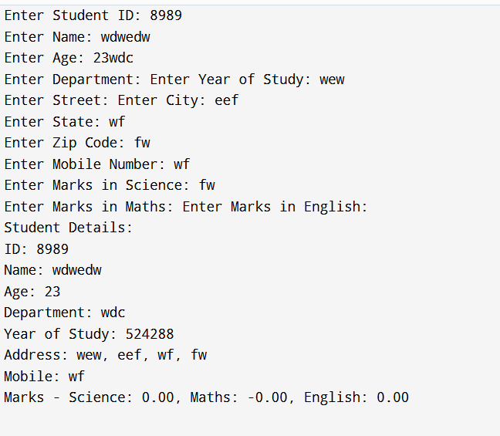
5. Write a C program to perform employee payroll processing using structures.
#include <stdio.h>
struct Employee {
int id;
char name[50];
float hours_worked;
float rate_per_hour;
float gross_salary;
};
int main() {
struct Employee emp;
printf("Enter Employee ID: ");
scanf("%d", &emp.id);
printf("Enter Name: ");
scanf("%s", emp.name);
printf("Enter Hours Worked: ");
scanf("%f", &emp.hours_worked);
printf("Enter Rate per Hour: ");
scanf("%f", &emp.rate_per_hour);
emp.gross_salary = emp.hours_worked * emp.rate_per_hour;
printf("\nEmployee Payroll Details:\n");
printf("ID: %d\n", emp.id);
printf("Name: %s\n", emp.name);
printf("Hours Worked: %.2f\n",
emp.hours_worked); printf("Rate per Hour: %.2f\n",
emp.rate_per_hour); printf("Gross Salary: %.2f\n",
emp.gross_salary);
return 0;
}
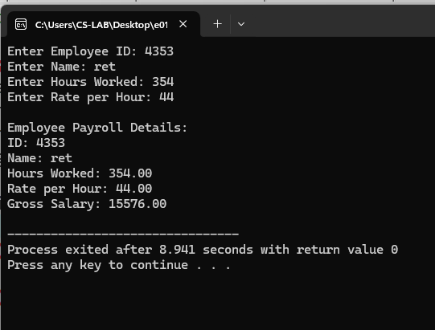
6. Write a C program using a structure to store and display student details. Define a structure named Student with the following members:
● rollNo (integer)
● marks (float)
● grade (character) The program should:
1. Read the student’s roll number and marks from the user.
2. Assign a grade based on marks as follows:
○ Marks ≥ 90 → Grade A ○ Marks ≥ 75 → Grade B ○ Marks ≥ 50 → Grade C ○ Marks < 50 → Grade D
3. Display the student’s details including the calculated grade.
#include<stdio.h>
struct sd{
int rollno;
char name[43];
float marks;
char grade;
};
int main(){
struct sd s1;
printf("roll no.");
scanf("%d",&s1.rollno);
printf("name ");
scanf("%s",&s1.name);
printf("marks");
scanf("%f",&s1.marks);
if (s1.marks>90) {s1.grade='A';}
else if (s1.marks>75) {s1.grade='B';}
else if (s1.marks>50) {s1.grade='c';}
else {s1.grade='f';}
printf("\nstudent details\n");
printf("%d\n",s1.rollno);
printf("%s\n",s1.name);
printf("%c\n",s1.grade);
return 0;
}
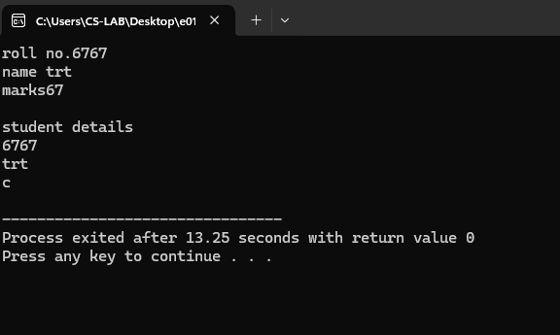
7. Write a C program using a structure to store and display employee details. Define a structure named Employee with the following members:
empId (integer)
salary (float)
grade (char)
The program should: Read the employee details from the user. Assign a grade based on the salary range as follows:
Salary ≥ 90000 → Grade A
Salary ≥ 75000 → Grade B
Salary ≥ 50000 → Grade C
Salary < 50000 → Grade D
Display the employee’s details including the calculated grade
#include<stdio.h>
struct emp{
int empid;
char name[23];
float s;
char grade;
};
int main(){
struct emp e1;
printf("employee id.");
scanf("%d",&e1.empid);
printf("name:");
scanf("%s",&e1.name);
printf("salary:");
scanf("%f",&e1.s);
if (e1.s>=100000) {e1.grade='A';}
else if (e1.s>=75000) {e1.grade='B';}
else if (e1.s>50000) {e1.grade='C';}
else {e1.grade='D';}
printf("\nstudent details\n");
printf("%d\n",e1.empid);
printf("%s\n",e1.name);
printf("%c\n",e1.grade);
return 0;
}